16.049 |  | Spring Rider Bee
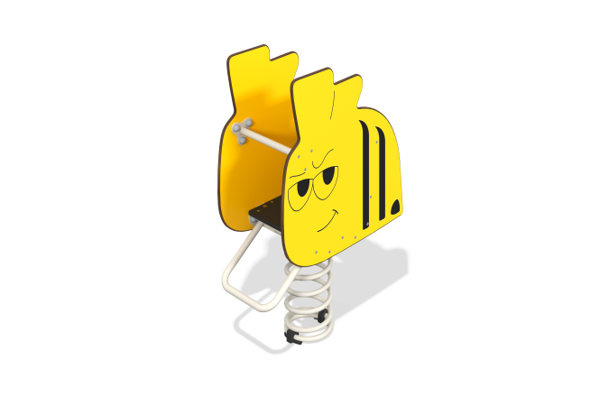

Size, mm: | 380x749x1156 | Weight, kg: | 43.03
Material characteristics
Main materials: laminated plywood with anti-slip coating, HPL plastic, metal, stainless fasteners.
Contents: base with spring – 1 set, rocking chair sides – 2 pcs., seat – 1 pc., backrest – 1 pc., crossbar – 2 pcs., fastening kit – 1 pc.
Design and color palette of equipment according to the sketch.
Rocking chair on a metal spring with two side panels made of HPL plastic 10 mm thick, a seat and back made of moisture-resistant laminated plywood 18 mm thick, a crossbar for legs and arms made of a round pipe with a diameter of 26.8 mm and a wall thickness of 2.8 mm. The spring is made of metal, dimensions 360x200x20 mm. Decorative elements and designs are applied using UV printing. The front side of the panel has a “Bee” print.
The complex uses stainless steel fasteners.
Element coverage:
- metal - powder zinc primer, powder paint.

