GW-05801 |  | Eco-wood Series Outdoor Playground GW-05801
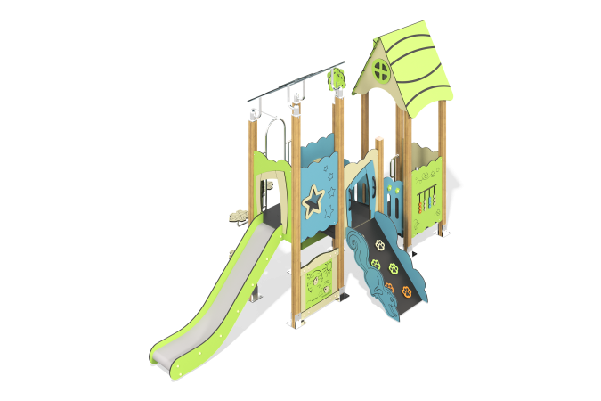

Size, mm: | 2700x5700x3800 | Weight, kg: | 0
Material characteristics
Material:
Plastic parts: The majority made of compact laminate board.
Post: Aluminum alloy.
Platform: Stainless steel base frame, compact laminate board.
Stair, bridge: Plastic (rubber) coated or powder coated.
Clamp, base, Post Cap: Aluminum Alloy.
Hardware Screws: 304 Stainless Steel, anti-theft screws.
Advantage:
A: Imported Nontoxic Plastic, Slide Thickness: 10mm; Other Plastic Thickness: 5mm.
B: Anti-UV, Anti-static, Anti-skid and Anti-crack.
C: Security and Environmental Friendly.
D：Metal Parts Proceeded Through Special Process; Surface With Antiskid PVC Coating/Powder Coating.

