LGTU-503 |  | Sports Station 503
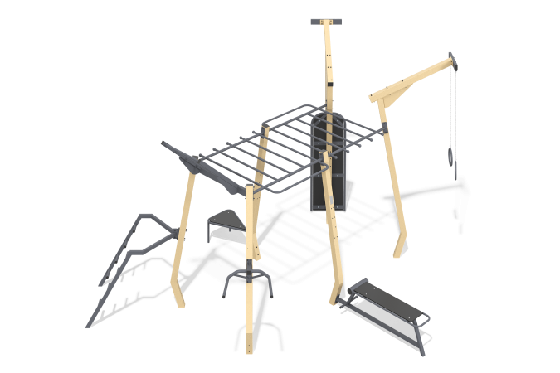

Size, mm: | 4772x5736x3491 | Weight, kg: | 402
Material characteristics
Length 5736 * width 4772 * height 3491 mm. Weight 602 kg
Purpose: The sports complex is designed for the development of all muscle groups and cardio training.
Materials: Structural steel (Pipe 100*100*4 GOST8639, 80*80*3 GOST8639, DN25*2.8 GOST3262, DN32*2.8 GOST3262; sheet 2 GOST 19903, 4 GOST 19903, 6 GOST 19903, 8 GOST 19903; circle 10 GOST2590, 16 GOST2590, 30 GOST2590; corner 35x35x3 GOST8509). TRS plywood, EPDM coating (polyurethane), plastic elements (plugs, caps) - (PVC plastic 0-40 GOST 5960, polyethylene ND GOST 16338)
Installation: Assembling the structure at the site of operation according to the instructions (included in the kit), concreting the supporting elements into the ground to a depth of 0.6 - 0.8 m.
Coating of elements: Polymer coating of metal. In ZE version - zinc coating of metal elements; ZEC - zinc coating of metal elements and polymer coating. Lumber coating - Remmers system.
Fasteners: Galvanized hardware.
Elements of the complex:
Metal stand – 4 pcs.
Canopy horizontal bar – 1 set
Canopy beams – 1 set
Canopy handrail – 1 set
Canopy press – 1 set
Handle canopy – 2 sets
Canopy horizontal bar-ladder – 1 set
Extended stand – 2 pcs.
Wall canopy – 1 set
Platform canopy for pacing – 1 set
Gymnastic ring canopy – 2 sets
Rope – 1 set
Set of hardware – 1 pc.

