MG3601 |  | Pole with rope on the slope
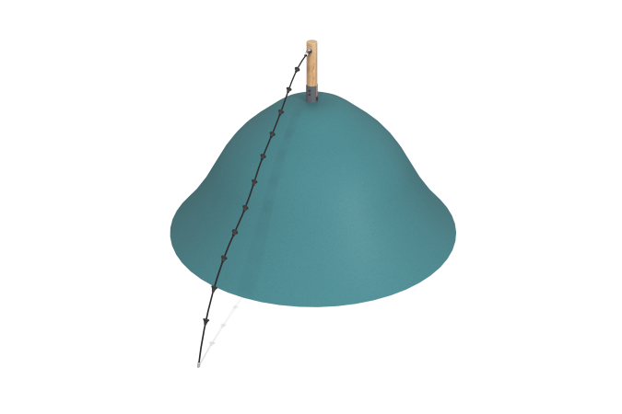

Size, mm: | 140x3130x2250 | Weight, kg: | 20.11
Material characteristics
Materials: rounded larch timber, polypropylene rope.
Package includes: pole - 1 pc., rope with ledges - 1 pc.
The play element is a pole made of rounded larch timber with a diameter of 140 mm, to which a polypropylene reinforced rope d = 16 mm with plastic ledges is attached.
Coating of elements:
- metal - zinc powder primer, powder paint;
- timber - glazing primer, water-dispersion varnish.

