MG3518 |  | Sports equipment Crossing
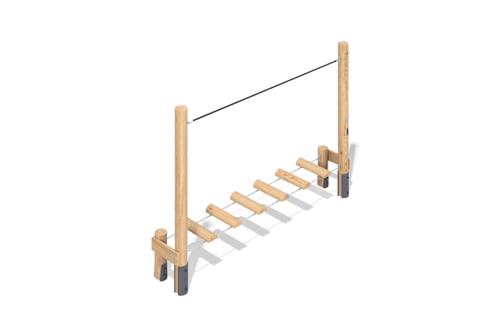

Size, mm: | 500x3000x2000 | Weight, kg: | 108.18
Material characteristics
Materials: softwood, metal, reinforced polypropylene rope, stainless steel.
Package includes: 4 support posts, 2 crossbars, 1 rope handrail, 6 steps, 1 fastener kit.
The support posts and steps are made of rounded larch timber with a diameter of 140 mm. The crossbars are made of larch boards measuring 140 x 35 mm.
The sports equipment includes a rope handrail made of six-strand reinforced polypropylene rope with a diameter of 16 mm.
The set uses stainless steel fasteners. Protruding threaded connections and exposed pipe sections are covered with plastic plugs.
Finishing:
- Metal: zinc powder primer, powder paint;
- Timber: translucent primer, water-based varnish.

