MG1104 |  | Sandpit Ship
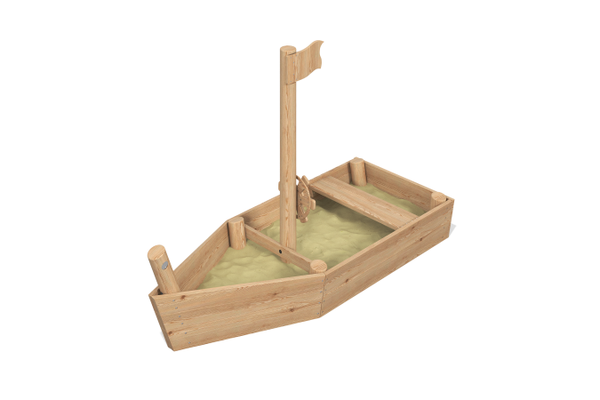

Size, mm: | 1205x3000x1990 | Weight, kg: | 114.5
Material characteristics
Main materials: softwood lumber, planed pine and/or larch boards, metal, birch plywood, stainless steel fasteners.
Package includes: 1 set of embedded parts; 6 posts; 5 sides; 1 decorative flag element; 1 bench; 1 steering wheel; 1 set of fasteners.
The sandbox consists of 6 posts and 5 sides. The posts are made of softwood lumber with a cross-section of 140 mm. The sides are made of planed larch boards measuring 35 x 190 mm. Decorative elements, such as the flag, are made of planed pine boards measuring 25 x 140 mm. The steering wheel is made of 12 mm thick birch plywood. The seat board is made of 35x140 mm larch board.
The set uses stainless steel fasteners. Protruding threaded connections and mounting holes are covered with plastic plugs.
Finishing:
- Metal: zinc powder primer, powder paint;
- Timber: translucent primer, water-based varnish.

