16.052 |  | Spring Rider Stump
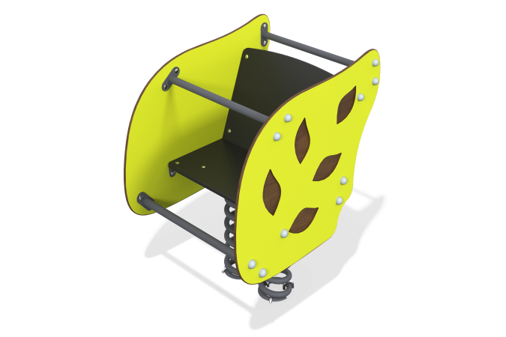

Size, mm: | 587x765x854 | Weight, kg: | 47.877
Material characteristics
Materials: HPL plastic, metal, moisture-resistant laminated plywood.
General description of the design
The product is a rocking chair on a metal spring, where the walls are made of HPL plastic decorated with the shape of a tree leaf and slots in the form of leaves.
Materials and components
Powder-painted steel with a layer of zinc-containing primer, HPL panels, laminated waterproof plywood, stainless steel fasteners.
The frame consists of the metal base of the rocking chair (platform-springs-platform), as well as straight and bent round metal pipes that determine the basic shape of the rocking chair.
The seat is made of high-strength, moisture-resistant laminated plywood 15 mm thick, lined with phenolic or melamine film 120-220 g/m2, with a signature “hexagonal structure” pattern.
The side walls are made of HPL plastic with a thickness of at least 10 mm. All edges are rounded using special knives or milling.
Installed on two end compression springs. The spring is fastened to the support platform using U-shaped clamps.

