32.034 |  | Parking bollard
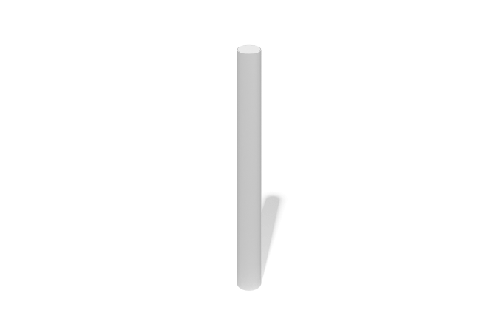

Size, mm: | 150x150x750 | Weight, kg: | 4.3793
Material characteristics
Primary materials: stainless steel, stainless steel fasteners.
Scope of supply:
parking bollard – 1 pc.;
fastener kit – 1 set.
The bollard is manufactured from a stainless steel tube with an outer diameter of 76.1 mm and a wall thickness of 2 mm.
The base flange is made from 4 mm thick stainless steel plate. The top cap is made from 2 mm thick stainless steel plate.
The assembly utilizes stainless steel fasteners throughout. For safety and aesthetics, the exposed threads of all bolted connections are covered with plastic protective caps.

