16.054 |  | Spring Rider Boombox
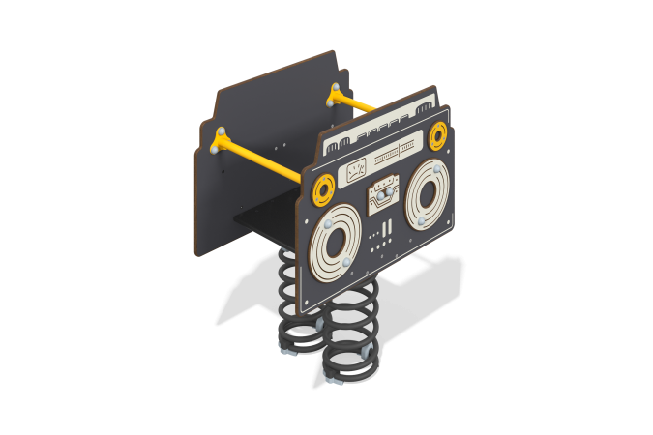

Size, mm: | 528x804x969 | Weight, kg: | 75.995109
Material characteristics
Materials: metal, HPL plastic, moisture-resistant laminated plywood.
General description of the design
The product is a rocking chair on two metal springs, where the walls are made of HPL plastic decorated with samples and overlays with printed patterns, visually depicting a music center.
Materials and components
Powder-painted steel with a layer of zinc-containing primer, HPL plastic, laminated waterproof plywood, stainless fasteners.
Frame
It consists of the metal base of the rocking chair (platform-springs-platform), as well as straight and bent round metal pipes, which are the handrails and limiters of the rocking chair. Mounted on two springs secured to a sheet steel base using U-shaped clamps.
The seat is made of high-strength, moisture-resistant laminated plywood 15 mm thick, lined with phenolic or melamine film 120-220 g/m2, with a signature “hexagonal structure” pattern.
The side walls are made of HPL plastic with a thickness of at least 10 mm. All edges are rounded using special knives or milling.
Installed on the end tension spring. The spring is fastened to the support platform using U-shaped clamps.

