28.019 |  | Youth Fitness Equipment Climber
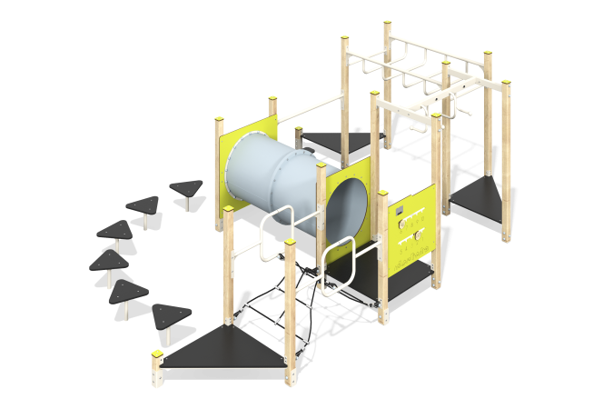

Size, mm: | 3626x5510x1960 | Weight, kg: | 321.03
Material characteristics
Main materials: softwood timber, planed softwood board, laminated plywood with anti-slip coating, HPL plastic, HDPE plastic, metal, stainless steel, reinforced polypropylene rope, stainless fasteners.
Contents: Embedded parts - 1 set, support posts - 15 pcs., stump posts - 8 pcs., lintels - 1 pc., handlebar - 1 set, handlebar beam with longitudinal handles - 1 pc. , transverse beam of the handle bar – 2 pcs., “Numbers” panel – 1 pc., handrail – 1 pc., square platform – 1 pc., triangular platforms – 3 pcs., post caps – 15 pcs., stump overlays – 6 pcs., log platform – 1 pc., rope bridge handrails – 2 pcs., rope mesh – 1 pc., tunnel - 1 pc., mounting kit - 1 pc.
Design and color palette of equipment according to the sketch.
The sports complex consists of 15 support posts, monkey bars, platforms, tunnel and rope crossings. The support posts are made of laminated coniferous timber with a cross-section of 80x80 mm. The profile is square, the corner radius is R10.
The platforms are made of laminated plywood 18 mm thick with an anti-slip coating.
The transition between platforms is presented in the form of a tunnel transition d=740 mm, consisting of separate segments made of HDPE plastic. The tunnel frame is HPL plastic, 10 mm thick.
The transition between the square and triangular platforms is presented in the form of a rope bridge made of six-strand reinforced polypropylene rope d=16 mm.
The rope bridge railings, connecting handrails and monkey bars are made of metal pipe with a diameter of 33.5 mm. The beams of the handlebar are made of a metal pipe with a diameter of 42.3 mm.
The "Numbers" gaming panel is made of double-sided HPL plastic with UV protection, 10 mm thick. Drawings are applied to the panel using engraving and UV printing.
Caps made of HPL plastic with UV protection 10 mm thick are installed on the upper part of the support posts.
The complex uses stainless steel fasteners. Protruding parts of threaded connections and open parts of pipes are closed with plastic plugs.
Element coverage:
- metal - powder zinc primer, powder paint;
- timber - glazing primer, water-dispersion varnish.

