23.196 |  | Game Panel Erudite
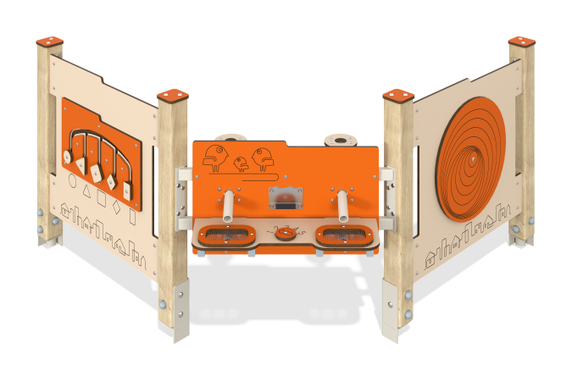

Size, mm: | 886x2084x865 | Weight, kg: | 48.44
Material characteristics
Material: softwood timber, HPL plastic, metal, stainless steel, stainless fasteners.
Contents: Assembled stands - 4 pcs., "Figures" game panel - 1 pc., game panel with sieve - 1 pc., "Illusion" game panel - 1 pc., fastening kit - 1 pc.
The educational element is a stand consisting of three game panels mounted on timber supports.
The support posts are made of laminated coniferous timber with a cross-section of 80x80 mm. The profile is square, the corner radius is R10.
The Scrabble game element is made of double-sided HPL plastic with UV protection, 10 mm thick. The frame of the developing element, on which the panels are fixed, is made of a 40x25 mm profile pipe with a wall thickness of 2 mm. All decorative elements such as sliders are made of 10 mm thick HPL plastic. The sieve on one of the panels is made of stainless steel with a thickness of 1.5 mm. The sand pipe is made of a round pipe with a diameter of 42.3 mm and a wall thickness of 2.8 mm. Drawings are applied to the panels using engraving and UV printing.
Caps made of HPL plastic with UV protection 10 mm thick are installed on the upper part of the support posts.
Game elements of the complex: “Shapes” panel with sliders – 1 pc., panel with a sieve – 1 pc., “Illusion” panel with a rotating circle – 1 pc.
The Scrabble game panel is designed for thematic play and motor skills development.
The gaming panel uses stainless steel fasteners. Protruding parts of threaded connections and open parts of pipes are closed with plastic plugs.
Element coverage:
- metal - powder zinc primer, powder paint;
- timber - glazing primer, water-dispersion varnish.

