28.077 |  | Sports and Play System
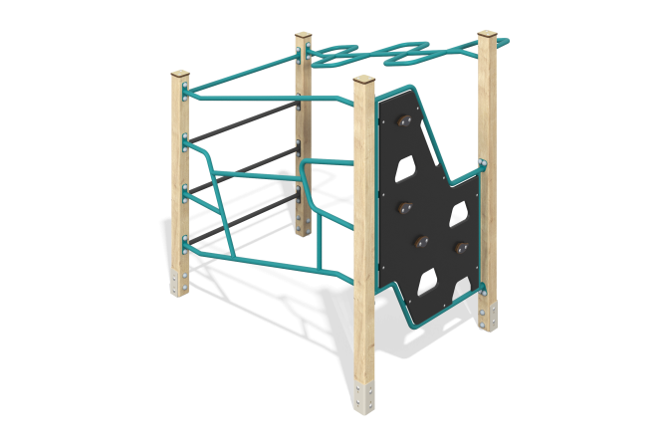

Size, mm: | 1320x1590x1710 | Weight, kg: | 91.44
Material characteristics
Materials: Coniferous wood, metal, HPL plastic, reinforced polypropylene rope.
Contents: support posts – 4 pcs; panel with ledges – 1 set; horizontal metal ladder – 1 piece; rope ladder - 1 piece; handlebar - 1 pc., fastening set - 1 set.
The complex consists of 4 support pillars with a cross-section of 80 mm x 80 mm, made from laminated veneer lumber, consisting of three layers of dry softwood boards. All posts are polished, the edges are rounded (rounding radius 20 mm). The treated surfaces are varnished. The upper ends of the pillars are closed with caps made of HPL plastic 10 mm thick.
The metal elements of the rungs of the complex and the stairs are made of a round pipe with a diameter of 26.8 mm and a wall thickness of 2.8 mm.
The first section contains a 14mm thick HPL panel with climbing hooks. The frame is made of a round pipe with a diameter of 26.8 mm and a wall thickness of 2.8 mm. The hooks on the panels are made of HPL plastic 10 mm thick. In other sections, ladders and a guide rail are installed, which are made of metal round pipes with a diameter of 26.8 mm and a wall thickness of 2.8 mm.
Caps made of HPL plastic with UV protection 10 mm thick are installed on the upper part of the support posts.
The complex uses stainless steel fasteners. The protruding parts of threaded connections and open parts of pipes are closed with plastic plugs.
Element coverage:
- metal - powder zinc primer, powder paint;
- timber - glaze primer, water-dispersion varnish.

