13.007 |  | Play System Balance
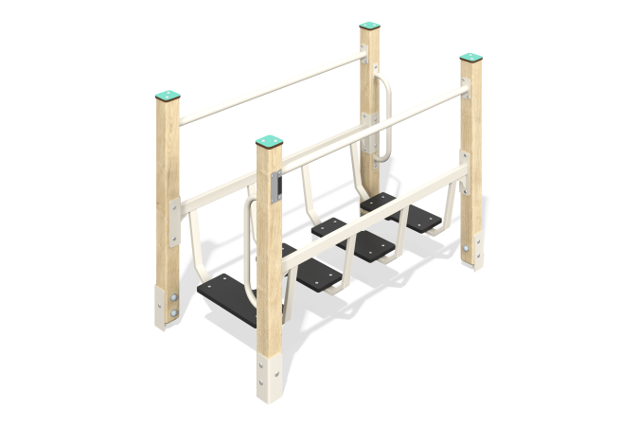

Size, mm: | 770x1450x1065 | Weight, kg: | 64.247
Material characteristics
Materials: laminated veneer lumber, moisture-resistant laminated plywood with an anti-slip layer 18 mm thick, metal, HPL plastic 10 mm thick.
The play element is a bridge on four supports made of laminated veneer lumber with a transition on a frame made of metal pipes and steps made of moisture-resistant laminated plywood with an anti-slip coating 18 mm thick. There are railings made of metal pipes on both sides of the transition between the posts. Handles (2 pcs.) are installed on the racks on both sides of the bridge.
The racks are made of laminated veneer lumber with a cross-section of 80mm x 80mm. Profile - square (R10 - corner radius). The top of the racks are covered with plastic caps.
Coating of elements: Polymer coating of metal; processing of lumber - glaze primer, water-dispersion varnish. Stainless steel fasteners are used.
Contents: Assembled racks - 4 pcs., handles - 2 pcs., step frame - 4 pcs., railings with adapters - 2 pcs., bridge steps - 4 pcs., fastening kit - 1 pc.

