13.199 |  | Play System Tunnel
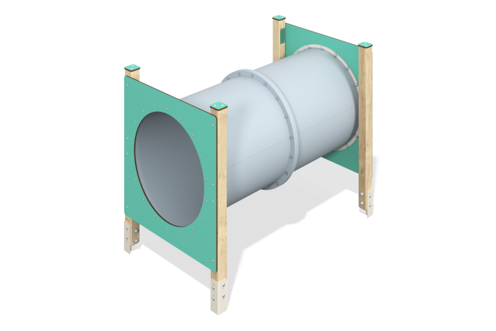

Size, mm: | 1000x1655x1315 | Weight, kg: | 80.196
Material characteristics
Main materials: softwood timber, planed softwood board, laminated plywood with anti-slip coating, HPL plastic, HDPE plastic, stainless fasteners.
Contents: embedded parts - 1 set, support posts - 4 pcs., fencing and decorative panels - 1 set, tunnel - 1 pc., fastening set - 1 pc.
Design and color palette of equipment according to the sketch.
The gaming module is presented in the form of a tunnel, consisting of separate segments made of HDPE plastic.
The enclosing elements are made of double-sided HPL plastic with UV protection, 10 mm thick.
The game element uses stainless steel fasteners. Protruding parts of threaded connections and open parts of pipes are closed with plastic plugs.
Element coverage:
- metal - powder zinc primer, powder paint;
- timber - glazing primer, water-dispersion varnish.

