35.034 |  | Podium-2
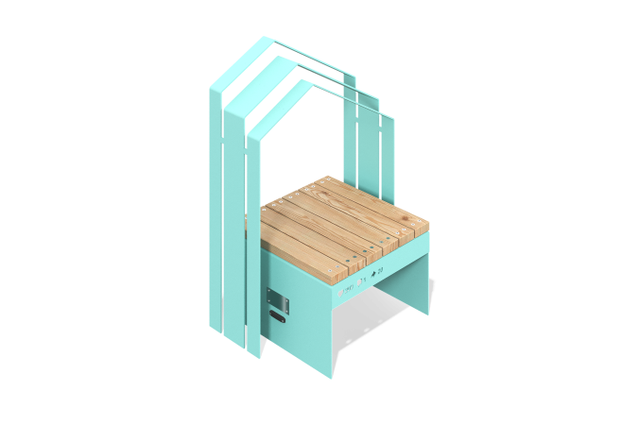

Size, mm: | 574x778x1079 | Weight, kg: | 102
Material characteristics
Materials: coniferous wood - larch, metal.
Equipment: podium - 1 piece, arch 1 piece.
The podium consists of support posts, on top of which boards are installed.
The boards are made of coniferous wood with a cross-section of 90x35 mm, the radius of rounding is R3. The support posts are a metal welded U-shaped structure made of 6 mm and 4 mm thick sheets. The arch (welded structure) is made of a 6 mm thick metal sheet.
The equipment uses stainless steel fasteners.
Coating of elements:
- metal - hot zinc primer, powder paint (RAL 6027 moire);
- beam - water-based varnish.

