35.036 |  | Obstacle course-2
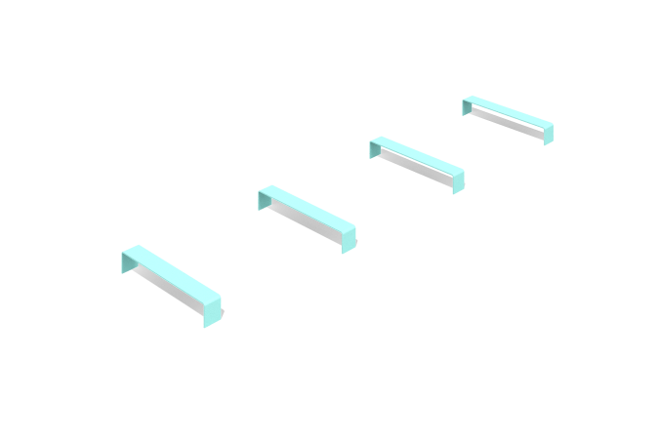

Size, mm: | 600x3334x91 | Weight, kg: | 33.0833
Material characteristics
Product dimensions:
Width - 600 mm; length - 3334 mm; height - 91 mm
Materials: metal.
Equipment: crossbar - 5 pcs.
The "Obstacle Course-2" element is an obstacle course made of metal crossbars for dogs. The crossbars of the product are made of a bent metal sheet with a thickness of 6 mm and metal heels with a thickness of 4 mm.
Coating of the elements:
- metal - powder zinc primer, powder paint

