13.010 |  | Play System Santorini
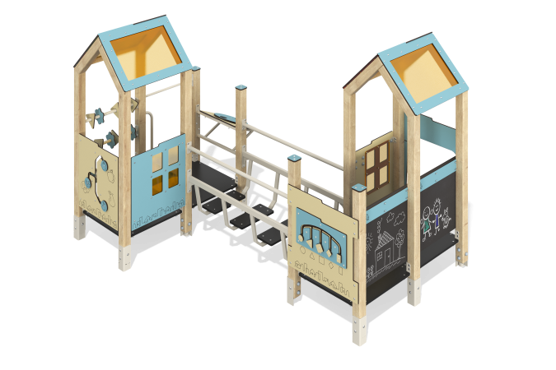

Size, mm: | 2143x2833x1895 | Weight, kg: | 247.01
Material characteristics
Main materials: softwood timber, laminated plywood with anti-slip coating, HPL plastic, metal, monolithic polycarbonate, stainless fasteners.
Contents: embedded parts – 1 set, support posts – 12 pcs., roof – 2 sets, floors – 2 sets, fencing and decorative panels – 1 set, drawing board – 1 pc., bridge-transition – 1 pc., bench – 1 pc., “Shapes” panel – 1 pc., abacus – 3 pcs., intercom – 1 pc., set of fasteners - 1 pc.
Design and color palette of equipment according to the sketch.
The playhouse consists of 2 houses. The support posts are made of laminated coniferous timber with a cross-section of 80x80 mm. The profile is square, the corner radius is R10.
The transition between the houses is presented in the form of a metal bridge made of profile pipes 50x25 mm and 40x20 mm with a wall thickness of 2 mm and steps made of laminated plywood 18 mm thick with an anti-slip coating.
The floor of the houses is made of 18 mm thick laminated plywood with an anti-slip coating.
The roof of the house is gable, made of a combination of frames made of HPL plastic with monolithic polycarbonate, onto which color coating is applied using UV printing.
The handles are made of metal pipe with a diameter of 26.8 mm and a wall thickness of 2.8 mm.
Metal crossbars are made of a round pipe with a diameter of 21.3 mm and a wall thickness of 2.8 mm.
The complex uses stainless steel fasteners. Protruding parts of threaded connections and open parts of pipes are closed with plastic plugs.
Element coverage:
- metal - powder zinc primer, powder paint;
- timber - glazing primer, water-dispersion varnish.

