13.195 |  | Play System Tuscany
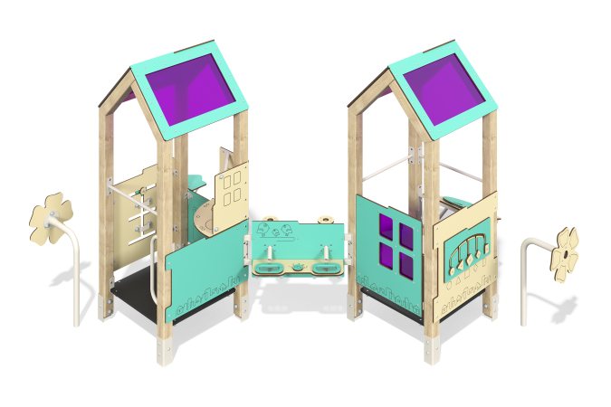

Size, mm: | 2692x2917x1925 | Weight, kg: | 200.28
Material characteristics
Main materials: softwood timber, laminated plywood with anti-slip coating, HPL plastic, metal, stainless steel, monolithic polycarbonate, stainless fasteners.
Contents: embedded parts - 1 set, support posts - 8 pcs., roof - 2 sets, floors - 1 set, fencing and decorative panels - 1 set, table - 1 pc., handle - 2 pcs., handrails - 3 pcs., "Kitchen" panel - 1 pc., panel "Who will eat whom?" - 1 pc., "Fruit" panel - 1 pc., intercom - 1 set, intercom pads - 2 pcs., stand for playing with sand - 1 pc., "Puzzle" panel - 1 pc., fastening kit - 1 pc.
Design and color palette of equipment according to the sketch.
The playhouse consists of 2 houses with platforms on supporting pillars. The support posts are made of laminated coniferous timber with a cross-section of 80x80 mm. The profile is square, the corner radius is R10.
The transition between the houses is presented in the form of a sand play stand. Decorative panels and game elements are made of double-sided HPL plastic with UV protection, 10 mm thick. Drawings are applied to panels and game elements using engraving and UV printing. Decorative inserts on the panels in the form of windows are made of monolithic polycarbonate 5 mm thick with color coating.
The floor of the houses is made of 18 mm thick laminated plywood with an anti-slip coating.
The roof of the house is gable, made of a combination of frames made of HPL plastic with monolithic polycarbonate, onto which color coating is applied using UV printing.
The handles are made of metal pipe with a diameter of 26.8 mm and a wall thickness of 2.8 mm.
Metal crossbars are made of a round pipe with a diameter of 21.3 mm and a wall thickness of 2.8 mm.
The complex uses stainless steel fasteners. Protruding parts of threaded connections and open parts of pipes are closed with plastic plugs.
Element coverage:
- metal - powder zinc primer, powder paint;
- timber - glazing primer, water-dispersion varnish.

