13.333 |  | Play System Riviera
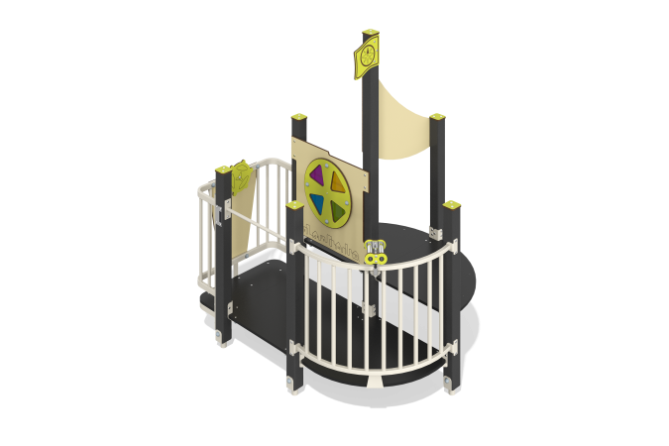

Size, mm: | 1485x1715x2060 | Weight, kg: | 135.127
Material characteristics
Main materials: softwood timber, laminated plywood with anti-slip coating, HPL plastic, metal, stainless steel, monolithic polycarbonate, stainless fasteners.
Contents: embedded parts - 1 set, support posts - 6 pcs., fencing and decorative panels - 1 set, handrails - 1 pc., arc balcony with binoculars - 1 pc., "Color disk" panel - 1 pc., game element "Steering wheel" - 1 pc., fastening set - 1 pc.
Design and color palette of equipment according to the sketch.
The game element consists of platforms that are located at different levels with interactive elements and an arc balcony with binoculars on support posts. The support posts are made of laminated coniferous timber with a cross-section of 80x80 mm. The profile is square, the corner radius is R10.
Decorative panels and game elements are made of double-sided HPL plastic with UV protection, 10 mm thick. Drawings are applied to panels and game elements using engraving and UV printing.
Decorative inserts on the panels in the form of windows are made of monolithic polycarbonate 5 mm thick with color coating.
The house uses stainless steel fasteners. Protruding parts of threaded connections and open parts of pipes are closed with plastic plugs.
Metal crossbars are made of a round pipe with a diameter of 21.3 mm and a wall thickness of 2.8 mm.
The arc balcony is made of a metal profile pipe 25x25 mm with a wall thickness of 2 mm, as well as transverse tubes with a diameter of 26.8 mm and a wall thickness of 2.8 mm. The binoculars consist of a stainless steel pipe with a diameter of 33.7 mm and a wall thickness of 2 mm, and stainless steel sheets with a thickness of 3 mm. The binocular glasses are made of monolithic polycarbonate, on top of which decorative overlays made of HPL plastic are installed. The binoculars are mounted on a “hinge” consisting of polypropylene reinforced rope
Element coverage:
- metal - powder zinc primer, powder paint;
- timber - glazing primer, water-dispersion varnish.

