13.022 |  | Play System Alaska
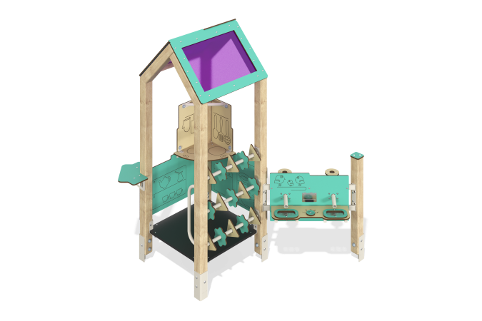

Size, mm: | 1545x1592x1932 | Weight, kg: | 102.17
Material characteristics
Main materials: softwood timber, laminated plywood with anti-slip coating, HPL plastic, metal, stainless steel, monolithic polycarbonate, stainless fasteners.
Contents: embedded parts - 1 set, support posts - 5 pcs., roof - 1 set, floors - 1 set, fencing and decorative panels - 1 set, table - 1 pc., stand for playing with sand - 1 pc., abacus - 1 pc., "Kitchen" panel - 1 pc., handle - 1 pc., set of fasteners - 1 pcs.
Design and color palette of equipment according to the sketch.
The house consists of one tower and an attached play element on support posts. The support posts are made of laminated coniferous timber with a cross-section of 80x80 mm. The profile is square, the corner radius is R10.
The floor of the house is made of 18 mm thick laminated plywood with an anti-slip coating.
The roof is gable, made of a combination of frames made of HPL plastic with monolithic polycarbonate, onto which color coating is applied using UV printing.
Decorative panels and game elements are made of double-sided HPL plastic with UV protection, 10 mm thick. Drawings are applied to panels and game elements using engraving and UV printing.
Handles and ties are made of metal pipe with a diameter of 26.8 mm and a wall thickness of 2.8 mm.
The house uses stainless steel fasteners. Protruding parts of threaded connections and open parts of pipes are closed with plastic plugs.
Element coverage:
- metal - powder zinc primer, powder paint;
- timber - glazing primer, water-dispersion varnish.

