23.036 |  | Educational Module Xylophone
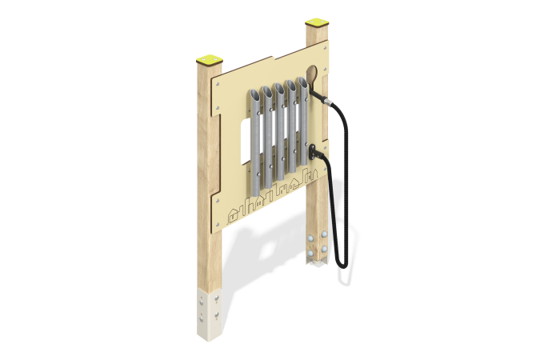

Size, mm: | 150x770x1160 | Weight, kg: | 22.126
Material characteristics
Material: softwood timber, HPL plastic, stainless steel, reinforced polypropylene rope, stainless fasteners.
Contents: embedded parts – 1 set, support posts – 2 pcs., game panels – 1 pc., rope – 1 pc., hammer – 1 pc., fastening set – 1 pc.
Design and color palette of equipment according to the sketch.
The educational element consists of two supports made of laminated veneer lumber, on which a Xylophone gaming panel with stainless steel tubes and a plastic handle secured with a polypropylene rope are fixed.
The support posts are made of laminated coniferous timber with a cross-section of 80x80 mm. The profile is square, the corner radius is R10.
The Xylophone gaming element is made of double-sided HPL plastic with UV protection, 10 mm thick. Drawings are applied to the panels using engraving. The xylophone pipes are made of stainless steel pipes with a diameter of 42.4 mm and a wall thickness of 2 mm, and stainless steel sheets with a thickness of 3 mm. A plastic handle 150 mm long is attached to a reinforced rope 800 mm long.
Caps made of HPL plastic with UV protection 10 mm thick are installed on the upper part of the support posts.
The gaming panel uses stainless steel fasteners. Protruding parts of threaded connections and open parts of pipes are closed with plastic plugs.
Purpose of the game “Xylophone”: You need to remove the handle from the panel and move it along the pipes on the panel. This action produces sound. The strength and nature of the blow affect how it will sound - quiet or loud, sharp or soft.
Element coverage:
- metal - powder zinc primer, powder paint;
- timber - glazing primer, water-dispersion varnish.

