26.057 |  | Workout System LGVO-26
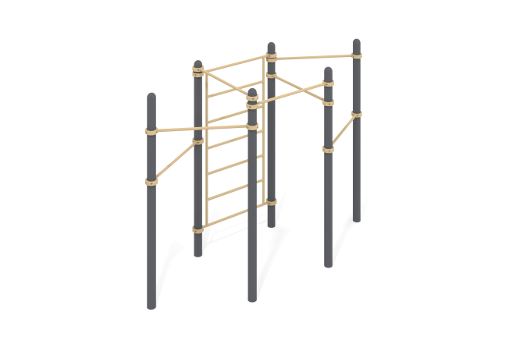

Size, mm: | 1358x3450x2554 | Weight, kg: | 232.086
Material characteristics
Materials: metal, powder paint. The complex consists of 6 support pillars made of a metal pipe with a diameter of 108 mm with a wall thickness of 3 mm, crossbars made of a round metal pipe with a diameter of 33.5 mm with a wall thickness of 2.8 mm and a vertical ladder. The upper part of the pillars is closed with an elliptical metal cap.
The crossbars are connected to the support posts using dismountable metal clamps with a diameter of 108 mm.
All existing metal parts are cleaned and painted with polyester powder paint.
All fasteners are stainless/galvanized.
Equipment:
Support pillars – 6 pcs.
Crossbars – 7 pcs.
Vertical ladder – 1 pc.
Metal clamps – 18 pcs.

