26.054 |  | Workout System LGVO-24
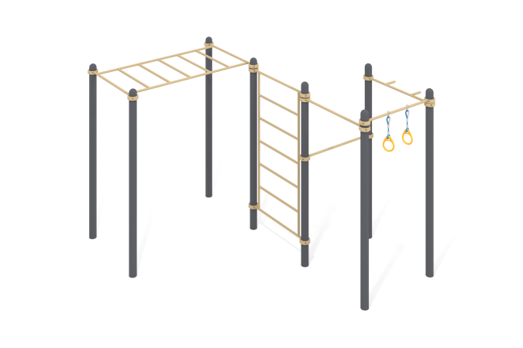

Size, mm: | 3512x3774x2554 | Weight, kg: | 291.235
Material characteristics
Materials: metal, powder paint, reinforced rope, plastic. The complex consists of 8 support pillars made of a metal pipe with a diameter of 108 mm with a wall thickness of 3 mm and crossbars made of a round metal pipe with a diameter of 33.5 mm and a wall thickness of 2.8 mm. The upper part of the pillars is closed with an elliptical metal cap.
The crossbars are connected to the support posts using dismountable metal clamps with a diameter of 108 mm.
Gymnastic rings are made of plastic. Fastening to the crossbar is carried out using a reinforced polypropylene rope with a diameter of 16 mm, consisting of six strands, each strand reinforced with eight metal wires. The steel wires are covered with twisted polypropylene split (woven polyester).
All existing metal parts are cleaned and painted with polyester powder paint.
Stainless steel/galvanized fasteners.
Equipment:
Support posts – 8 pcs.
Crossbars – 3 pcs.
Crossbar with rings – 1 set.
Vertical ladder – 1 pc.
Horizontal ladder – 1 pc.
Metal clamps – 16 pcs.

