38.007 |  | Tribune for 24 seats with aisle
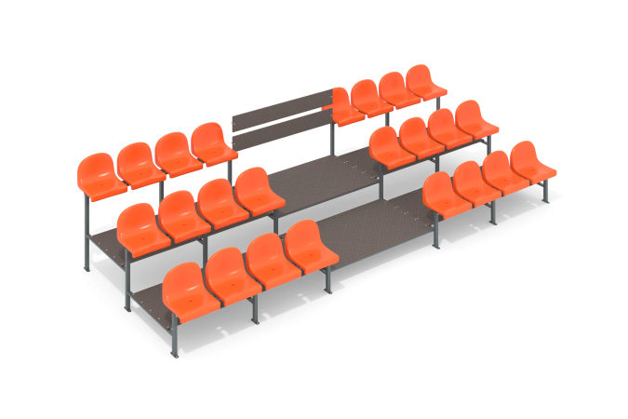

Size, mm: | 2338x5270x1309 | Weight, kg: | 283.86
Material characteristics
Materials: Moisture-resistant laminated birch plywood with anti-slip coating, metal, plastic.
The design consists of seat frames consisting of a 40x20 profile pipe with a width of 2 mm, module frames, and floor braces. The floors are made of moisture-resistant laminated birch plywood with an anti-slip coating. The seats are made of plastic. The floor stretcher consists of a profile pipe 40mm x 20mm and 2mm wide.
The tribune modules are joined together: 2 sections of seats and a passage sector. Stainless fasteners are used on the seats to prevent rust.
The ends of the pipes are closed with plastic plugs.
All available metal parts are painted with polyester powder paint.
The fastening kit is galvanized and stainless.
Contents: Seat frame – 6 pcs., Module frame – 4 pcs., Floor stretcher – 12 pcs., Floor – 7 pcs., Plastic seats – 24 pcs., Fastening kit – 1 pc.

