26.053 |  | Workout System LGVO-22
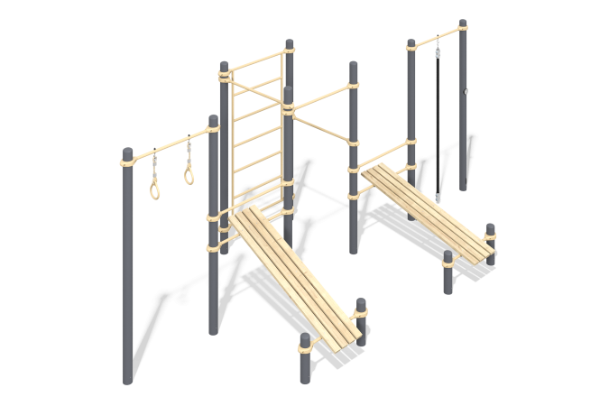

Size, mm: | 2955x6190x2554 | Weight, kg: | 393.013
Material characteristics
Materials: metal, powder paint, wood, varnish, plastic, reinforced rope.
The complex consists of 12 support pillars made of a metal pipe with a diameter of 108 mm with a wall thickness of 5 mm and crossbars made of a round metal pipe with a diameter of 33.5 mm and a wall thickness of 3.2 mm. The upper part of the pillars is closed with an elliptical metal cap.
The crossbar is connected to the support posts using dismountable metal clamps with a diameter of 108 mm.
The complex includes two abdominal benches, a crossbar with rings, a vertical ladder and four horizontal bars.
The rings are made of plastic. Fastening to the crossbar is carried out using a reinforced polypropylene rope with a diameter of 16 mm consisting of six strands, each strand is reinforced with eight metal wires. The steel wires are covered with twisted polypropylene split (woven polyester).
The surface of the benches for the press is made of dry coniferous boards with a cross-section of width 30 mm x length 100 mm. All boards are sanded, the top edges are rounded. The treated surfaces are covered with tinted and colorless varnish.
All existing metal parts are cleaned and painted with polyester powder paint.
All fasteners are galvanized.
.
Elements of the complex:
Pillar - 12 pcs.
Gymnastic bench frame height 900 mm (width 792 mm x length 1450 mm) - 2 pcs.
Crossbar - 2 pcs.
Crossbar for rings length 1210 mm - 1 pc.
Vertical ladder width 1210 mm x length 2000 mm - 1 pc.
Crossbar for rope - 1 pc.
Crossbar 3 pcs.
Clamp - 26 pcs.
Rope insert - 1 pc.
Board length 2000 mm - 8 pcs.
Climbing rope + mortgage - 1 pc.
Ring - 2 pcs.
Fastening kit - 1 pc.

