26.004 |  | Bench For rest
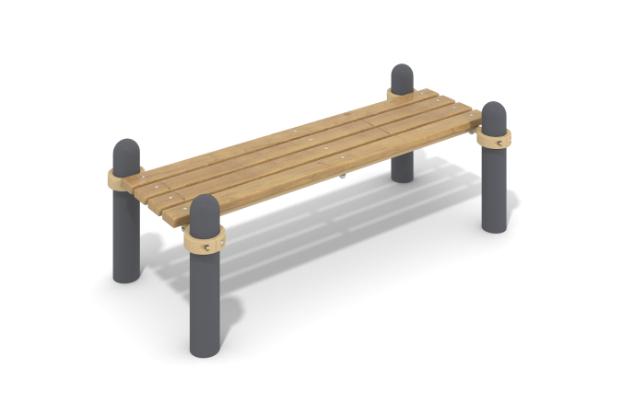

Size, mm: | 758x1635x554 | Weight, kg: | 74.709
Material characteristics
Materials: metal, powder paint, wood, varnish.
The rest bench consists of four support pillars made of a metal pipe with a diameter of 108 mm with a wall thickness of 3 mm, two crossbars made of a round metal pipe with a diameter of 33.5 mm and a wall thickness of 2.8 mm.
The upper part of the pillars is closed with an elliptical metal cap.
The crossbars are connected to the support posts using dismountable metal clamps 108 WORKOUT.
The rest bench is made of four dry coniferous boards with a section
35 mm x 90 mm. All boards are sanded, the top edges are rounded. The treated surfaces are covered with tinted and colorless varnish.
All existing metal parts are painted with polyester powder paint.
Stainless steel/galvanized fasteners.
Contents: support posts – 4 pcs; crossbars – 2 pcs; clamps – 4 pcs., boards 4 pcs.

