26.055 |  | Workout System Multi-levelled double Pullup
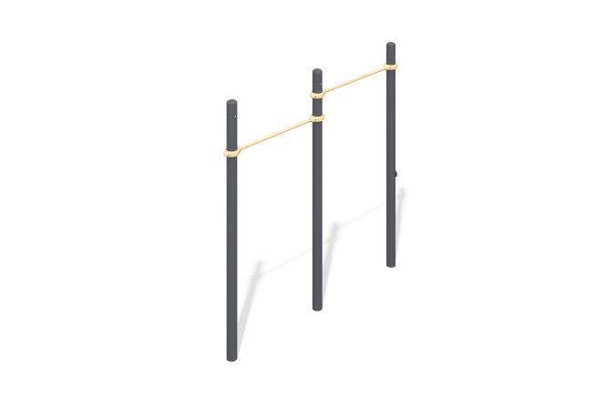

Size, mm: | 260x2676x2605 | Weight, kg: | 87.44
Material characteristics
Materials: metal, powder paint, wood, varnish.
The complex consists of three support pillars made of a metal pipe with a diameter of 108 mm with a wall thickness of 3 mm and crossbars made of a round metal pipe with a diameter of 33.5 mm and a wall thickness of 2.8 mm. The upper part of the pillars is closed with an elliptical metal cap.
The crossbars are connected to the support posts using dismountable metal clamps 108 WORKOUT.
All existing metal parts are painted with polyester powder paint.
All fasteners are galvanized.
Contents: support posts – 3 pcs., crossbars – 2 pcs., clamps – 4 pcs.

