26.024 |  | Workout System 5 Pullups and AB bench
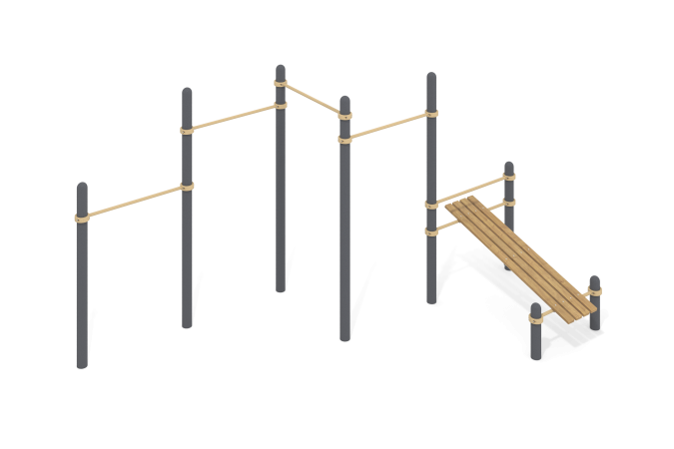

Size, mm: | 2955x4982x2554 | Weight, kg: | 221.842
Material characteristics
Materials: metal, powder paint, wood, varnish. The complex consists of 8 support pillars made of a metal pipe with a diameter of 108 mm with a wall thickness of 3 mm and crossbars made of a round metal pipe with a diameter of 33.5 mm and a wall thickness of 2.8 mm.
The upper part of the pillars is closed with an elliptical metal cap.
The crossbars are connected to the support posts using dismountable metal clamps 108 WORKOUT.
The complex includes a press bench and horizontal bars.
The surface of the benches for the press is made of dry coniferous boards with a cross-section of 35 mm x 90 mm. All boards are sanded, the top edges are rounded. The treated surfaces are covered with tinted and colorless varnish.
All existing metal parts are cleaned and painted with polyester powder paint.
All fasteners are galvanized.
Equipment:
support pillars – 8 pcs; crossbars – 5 pcs; clamps – 14 pcs.; Abdominal bench – 1 pc.
Fastening kit - 1 pc.

