26.026 |  | Workout System Stop with stops for push-up
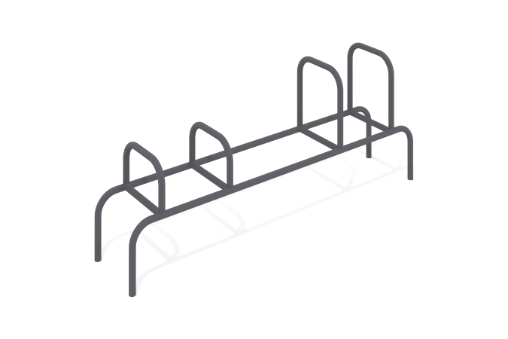

Size, mm: | 482x2382x963 | Weight, kg: | 36.82
Material characteristics
Materials: metal, powder paint.
The bench is made of a metal pipe with a diameter of 42 mm and a wall thickness of 3 mm.
All existing metal parts are painted with polyester powder paint.
Equipment:
Bench with push-up stops assembled - 1 set.

