26.013 |  | Workout System Parallel Bars
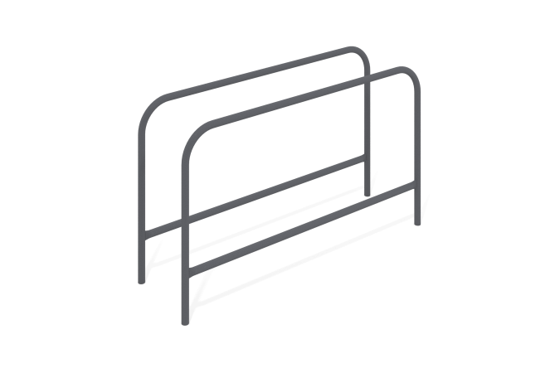

Size, mm: | 600x2040x1202 | Weight, kg: | 55.282
Material characteristics
Materials: metal, powder paint.
The parallel bars are made of a metal pipe with a diameter of 42.3 mm and a wall thickness of 3 mm using a metal pipe with a diameter of 33.5 mm and a wall thickness of 3 mm.
All existing metal parts are painted with polyester powder paint.
All fasteners are galvanized.
Equipment:
Complete bars - 1 set.

