26.002 |  | Workout System Snake hand-walker, Swedish wall and Pullups
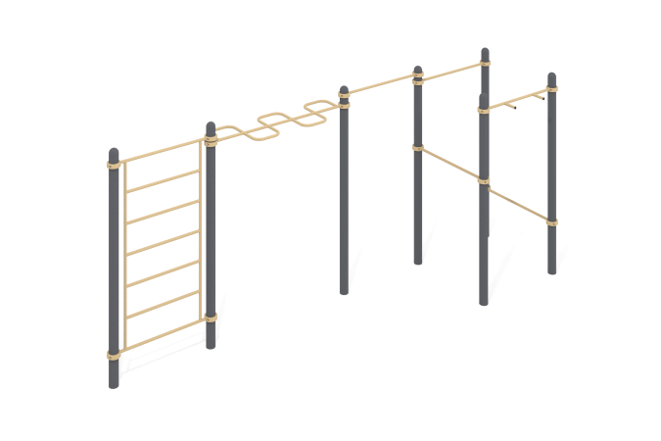

Size, mm: | 1694x5682x2554 | Weight, kg: | 258.574
Material characteristics
Materials: metal, powder paint.
The complex consists of 7 support pillars made of a metal pipe with a diameter of 108 mm with a wall thickness of 3 mm, 1 horizontal bar with hammers, 1 wall bars, 1 snake handlebar and 4 crossbars made of a round metal pipe with a diameter of 33.5 mm with a wall thickness of 2.8 mm.
The upper part of the pillars is closed with an elliptical metal cap.
The connection of the wall bars, snake bars, horizontal bar with “hammers” and crossbars to the support posts is made using dismountable metal clamps with a diameter of 108 mm.
All existing metal parts are painted with polyester powder paint.
All fasteners are galvanized.
Equipment:
Support pillars – 7 pcs.
Wall bars – 1 pc.
Handle-snake – 1 pc.
Horizontal bar with “hammers” – 1 pc.
Crossbars – 4 pcs.
Clamps – 16 pcs.
Fastening kit - 1 pc.

