40.020 |  | Meteor
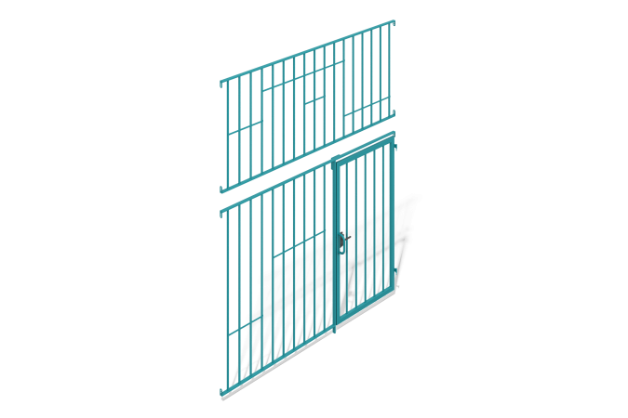

Size, mm: | 204x2920x3600 | Weight, kg: | 86.757
Material characteristics
The span is a structure of two sections, a gate and a mortgage.
The sections of the structure are made of profile metal rectangular pipes welded together with a cross-section of 40 mm x 20 mm and a wall thickness of 2 mm and
profile metal square section 20 mm x 20 mm and a wall thickness of 1.5 mm; connecting plates made of sheet steel 3 mm thick are welded to the ends of the rectangular profile.
Along the entire length of the upper section of the span, strips of metal 3 mm thick are welded at different levels. A stop-limiter for the gate made of 3mm thick sheet metal is welded on the lower section. The gate is made of profile metal pipes welded together
rectangular cross-section 40 mm x 20 mm and wall thickness 2 mm and
profile metal square section 20 mm x 20 mm and wall thickness 1.5 mm. Loops for hanging on a pole are welded along the length of the gate; on the other side there is a cutout for a latch. The lower section is connected to a mortgage made of a profile metal pipe with a square section of 40 mm x 40 mm and a wall thickness of 2 mm, flanges at both ends, with a bolted connection
Comes with a latch.
All open parts of the pipes are closed with plastic plugs of the appropriate size.
The spans are painted with polymer paint.

