34.151 |  | Park bench (round)
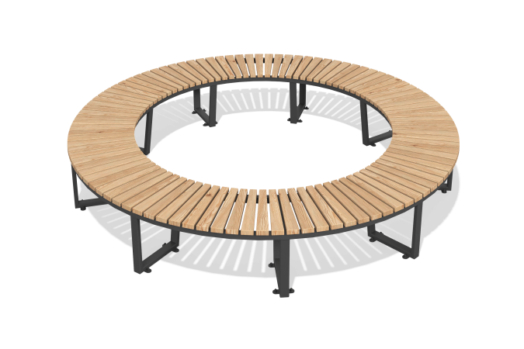

Size, mm: | 3000x3000x450 | Weight, kg: | 130
Material characteristics
Materials: metal, wood, powder paint.
The frame of the bench is made of profile pipe with high-tech processing, painted with glossy polyester powder paint. Seat frame - metal profile pipe with a cross-section of 25mm x 25mm, wall thickness 1.5 mm, legs - metal profile pipe with a cross-section of 40mm x 20mm, wall thickness 1.5mm and 20mm x 20mm, wall thickness 1.5mm.
The seat consists of bars measuring 95mm x 37mm x 450mm, made from AB class softwood. The bars are treated with antiseptics and painted with tinting impregnations.

