13.102 |  | Play System Tellurium
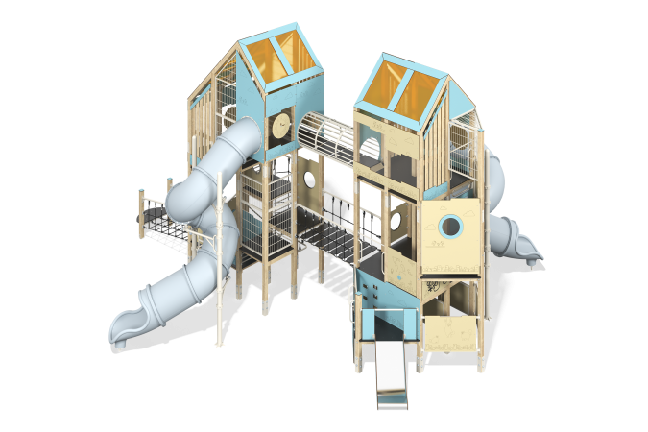

Size, mm: | 9523x9905x5969 | Weight, kg: | 6860.05
Material characteristics
Main materials: softwood timber, planed softwood board, laminated plywood with anti-slip coating, HPL plastic, HDPE plastic, metal, stainless steel, monolithic polycarbonate, reinforced polypropylene rope, stainless fasteners.
Contents: embedded parts - 1 set, support posts - 23 pcs., roofs - 2 sets, floors - 1 set, straight slide h=0.7 m - 1 pc., supports for screw slides - 4 pcs., tunnel screw slide - 2 pcs., metal mesh fences - 11 pcs., vertical wooden fences - 5 pcs., fencing and decorative panels - 1 set, rope mesh - 1 piece, rope bridge - 1 piece, fastening kit - 1 piece, metal tunnel - 1 piece.
Design and color palette of equipment according to the sketch.
The gaming complex consists of 2 multi-level towers. The support posts are made of laminated softwood timber with a cross-section of 100x100 mm. The profile is square, the corner radius is R10.
The transition between the towers is presented in the form of a rope bridge made of six-strand reinforced polypropylene rope d=16 mm with steps made of laminated plywood 18 mm thick with an anti-slip coating. The second transition is presented in the form of a metal tunnel, where the floor is made of laminated plywood 18 mm thick with an anti-slip coating. The rope bridge railings and tunnel passage are made of a metal pipe with a diameter of 42.3 mm and a wall thickness of 2.8 mm.
The floor frames are planed softwood boards with a section of 100x30 mm, 100x40 mm. The floors and steps are made of laminated plywood 18 mm thick with an anti-slip coating.
The roofs of the towers are gable, made of a combination of frames made of HPL plastic 10 mm thick with monolithic polycarbonate 5 mm thick, onto which color coating is applied using UV printing.
Game elements, fencing and decorative panels are made of double-sided HPL plastic with UV protection, 10 mm thick. Drawings are applied to panels and game elements using engraving and UV printing. Decorative inserts on the panels in the form of windows are made of monolithic polycarbonate 5 mm thick with color coating. Transparent panels are made of monolithic polycarbonate 10 mm thick. Vertical wooden fencing consists of planed softwood boards with a cross-section of 100x30 mm. Mesh fencing is made using Bastion galvanized metal mesh.
Game elements:
- game panels “Gears”, “Illusion”, “Interactive Circle”.
Climbs:
- vertical rope meshes made of six-strand reinforced polypropylene rope d=16 mm on a frame made of metal pipe with a diameter of 42.3 mm and a wall thickness of 2.8 mm.
The handles are made of metal pipe with a diameter of 26.8 mm and a wall thickness of 2.8 mm.
The play complex includes 2 straight and 1 spiral tunnel slides.
A straight slide h=0.7 m consists of a slope and sides, in turn made of stainless steel sheet 1.5 mm thick and HPL plastic 10 mm thick. The launch pads for straight slides are equipped with a metal crossbar made of a round pipe with a diameter of 21.3 mm and a wall thickness of 2.8 mm.
Spiral tunnel slides are composed of separate segments made of HDPE plastic. The supports of the screw slide are made of a metal pipe with a diameter of 108 mm and a wall thickness of 3 mm. The slide is additionally supported on metal supports made of a pipe with a diameter of 33.5 mm with a wall thickness of 2.8 mm, protruding from the support posts, as well as on metal clamps with an outer diameter of 140 mm.
The complex uses stainless steel fasteners. Protruding parts of threaded connections and open parts of pipes are closed with plastic plugs.
Element coverage:
- metal - powder zinc primer, powder paint;
- timber - glazing primer, water-dispersion varnish.

