23.021 |  | Educational Module Glockenspiel
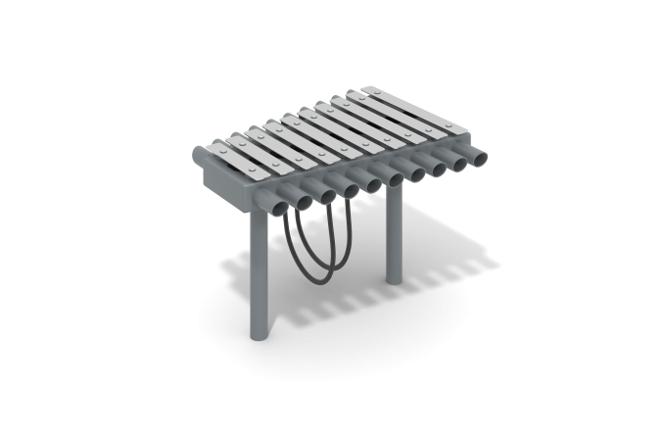

Size, mm: | 724x844x588 | Weight, kg: | 55
Material characteristics
Materials: moisture-resistant birch plywood, metal, acrylic paint, powder paint.
The supporting legs of the metallophone are made of a metal round pipe with a diameter of 57 mm.
The body is made in the form of a cone made of steel with a wall thickness of 3 mm. Case thickness 83 mm. On two long side faces there are metal pipes with a diameter of 57 mm and a length of 125 mm, 10 pieces per side.
There are 10 metal plates with rounded corners installed on the top cover. The plates are made of metal 4 mm thick and have a width of 60 mm. The length of the smallest plate is 233.33 mm, and the largest is 450 mm. The plates have different sizes, which gradually increase evenly from smallest to largest. There must be a gap between the plate and the body.
The sticks for playing the metallophone are made of high-strength, moisture-resistant birch plywood 21 mm thick.
All products made of metal are coated with polyester powder paint.
Elements made of plywood are painted in two layers of acrylic paint and have a special anti-graffiti coating.
All fasteners are galvanized.
Contents: metallophone assembly – 1 set;

