32.007 |  | Bike Parking Module Alpha
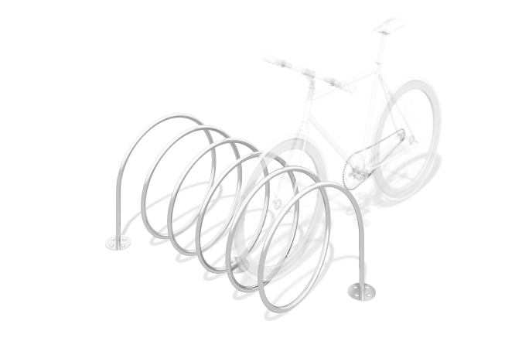

Size, mm: | 740x1400x630 | Weight, kg: | 0
Material characteristics
Materials: metal
Package includes: bicycle parking - 1 pc., fastener kit - 1 pc.
The bicycle parking support posts are made of a metal pipe with a diameter of 26.8 mm and a wall thickness of 2.8 mm and are fixed to a frame made of a metal profile with a cross-section of 40x20 mm.
The base frame has embedded elements for concreting, also made of a metal pipe with a diameter of 26.8 mm. All available metal parts are coated with polyester powder paint RAL 7012 (gray color).
The protruding parts of the threaded connections and open parts of the pipes are covered with plastic plugs.
Coating of elements:
- metal - dark primer + varnish

