26.058 |  | Workout System Triple cascade
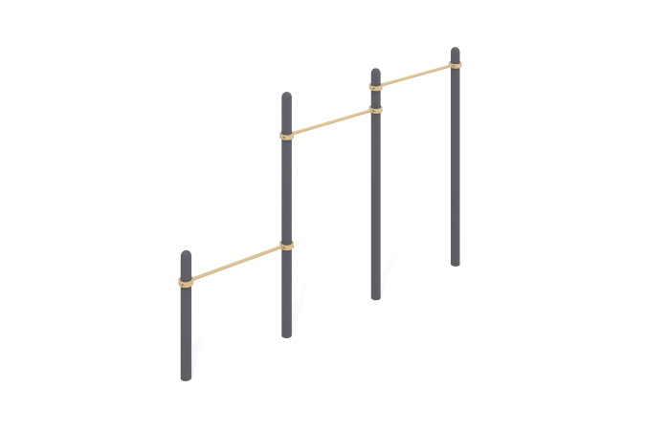

Size, mm: | 150x3774x2554 | Weight, kg: | 109.178
Material characteristics
Materials: metal, powder paint.
The complex consists of four support pillars made of a metal pipe with a diameter of 108 mm with a wall thickness of 3 mm and three crossbars made of a round metal pipe with a diameter of 33.5 mm and a wall thickness of 2.8 mm.
The upper part of the pillars is closed with an elliptical metal cap.
The crossbars are connected to the support posts using 108 mm collapsible clamps.
All existing metal parts are painted with polyester powder paint.
All fasteners are galvanized.
Equipment:
Support pillars – 4 pcs.
Crossbars – 3 pcs.
Clamps – 6 pcs.
Fastening kit - 1 pc.

