13.106 |  | Play System Symbol
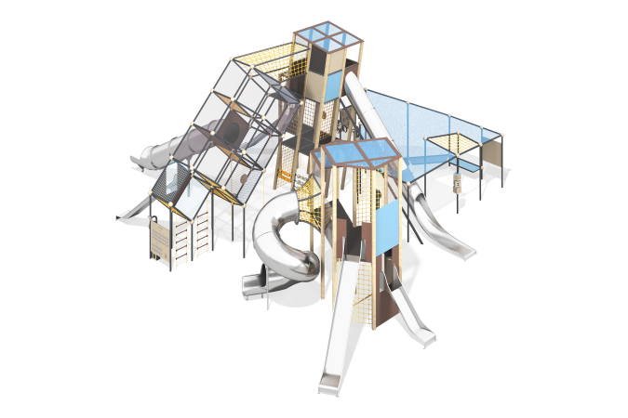

Size, mm: | 12700x14400x5900 | Weight, kg: | 0
Material characteristics
The concept of the play complex is based on the combination of the process of learning about various symbols in human life and classical interaction with the complex - climbing on different levels, descending from straight and spiral slides and other activities.
The frame of the complex in different modules consists of metal pipes and wooden
glued beams, consisting of three layers of dry coniferous boards. The elements are connected by rope manholes and passages. The entrances to the complex are designed as rope ladders, rope nets, free areas between the elements of the frame. The complex has seven slides: four open, three tunnel.
Materials and components
Powder-painted steel with a layer of zinc-containing primer, HDPE plastic and (or) HPL panels, laminated waterproof plywood, polypropylene six-strand reinforced rope, stainless steel fasteners.
Metal parts are coated with two layers: the first layer is a zinc-containing powder primer, which is a powder mixture based on epoxy resin, zinc and target additives, polymerized in a high-temperature chamber. The finishing layer is a polyester powder paint, which is a homogenized powder mixture of polyester resin, hardeners, pigments, fillers and modifiers selected to ensure weather resistance and light resistance. The finishing layer is polymerized in a high-temperature chamber.
The following components are used in the design: plastic plugs for pipe ends, plastic composite caps for fasteners, stainless steel fasteners, special fasteners for swing hangers, stainless steel chain. The frame of the tent module and the diagonal add-on module consists of steel pipes with a diameter of 89 mm and a wall thickness of 3 mm and a diameter of 108 mm with a wall thickness of 3 mm, additional frame elements are made of pipes DN25 (diameter 33.5 mm) with a wall thickness of 2.8 mm. To connect the pipes, special load-bearing spherical nodal joints are used, made of high-quality structural carbon steel, structural cast elements in the form of hemispheres with covers made of steel sheet and decorative elements. All frame metal elements are painted with powder paint with a layer of zinc-containing primer.
All metal parts undergo cleaning, degreasing and shot blasting before applying coatings.
The frame of the inclined tower and the hexagonal tower consists of glued beams with a section of 100x100 mm. Coniferous boards and steel ties made of round and profile pipes are used as tightening elements. Decorative, structural and play panels are made of durable, moisture-resistant and UV-resistant HDPE plastic 15 mm thick and HPL 10 mm thick.
Rope nets are made of UV-resistant polypropylene six-strand reinforced rope with a diameter of 16 mm. Rope connections are made of durable plastic and (or) specialized stainless steel or aluminum fasteners.
Platform floors are made of high-strength moisture-resistant laminated plywood, covered with phenolic or melamine film 120-220 g / m2, with a signature pattern "hexagonal structure".
All edges of parts made of sheet plastics, HDPE, HPL are processed and smoothed using special edge knives or milling. The complex includes up to seven slides made of 2 mm thick stainless steel - four open types, two straight tunnel slides and one screw tunnel slide made of plastic. Straight open slides are made of a single sheet of 2.0 mm thick stainless steel. The upper edges of the sides are protected by a round stainless steel tube with a diameter of 26.9 mm and a wall thickness of 2 mm. The slope and sides of the slide are made of one solid sheet of stainless steel, have no welds or gaps where the slope of the slide transitions to the sides. In the upper part, the slide has a flange with five holes, 9 mm in diameter. The flange of the slide is fastened to the complex using bolts. The angle between the slope of the slide and the side is 90º. The starting platform of the slide has a horizontal crossbar, also made of a round stainless steel pipe with a diameter of 26.9 mm, preventing children from running out onto the slope. The slide's support legs are made of a round stainless steel pipe with a diameter of 26.9 mm and are an extension of the tube that covers the edge of the side.
Tunnel slides are made of 2.0 mm thick stainless steel segments. The slide consists of individual segments with an internal diameter of 760 mm. The parts of the slide are connected by flanges, 4 mm thick, located at the ends on each side of the Pipe (segment). In the upper part, the slide has a flange 4 mm thick, with sixteen holes of 9 mm. The flange of the slide is fastened to the complex using bolts. The flanges of individual elements are also connected using bolts through 9 mm holes.
The lower part of the tunnel slide has a straight, open "braking" section, the edges of the sides of which are protected by a round stainless steel tube with a diameter of 26.9 mm and a wall thickness of 2 mm. The slide's support legs are made of a round stainless steel pipe with a diameter of 26.9 mm and are a continuation of the tube covering the edge of the side.
Additional vertical support elements of the tunnel slide are made of a stainless steel pipe with a diameter of 89 mm and a wall thickness of at least 3 mm.
The complex includes manholes and "nets" made of reinforced polypropylene rope with a diameter of 16 mm, consisting of six strands, each strand is reinforced with eight metal wires.
The steel wire is covered with twisted polypropylene split (braided polyester). The tensile load is at least 3,300 kg. The tensile strength is 1.570 N / mm².
The complex includes special developments - interactive elements, exhibits, educational stands and game modules. Braille
Module dimensions: 420 x 1170 x 1470 mm
The exhibit is located on the outside of the complex, between two metal stands.
A panel with the Russian Braille alphabet, where each letter is tactile.
Braille must be standardized in size according to GOST R 56832-2015 Braille. Requirements and dimensions, GOST R dated October 28, 2015 No. 56832-2015
Shadow theater
Dimensions without screen (optional): 1280 x 1470 mm
The element is located on the outside of the complex.
Turning the generator handle turns on a spotlight, under which you can place objects and see their shadow on the screen (optional). A stand with tips on how to show animals or other figures with your hands is installed nearby. Encryptor-decoder
The element has two nodes connected to each other by an electric wire and a speaking tube. One node (A) is located under the awning of the complex, the other (B) is on the upper floor of the inclined tower.
At communication point A there is a generator that powers the button and the sound source. When the button is pressed, the sound signals "dot" and "dash" (depending on the duration of pressing) go to communication point B. At point B there is a board with chalk for recording and decoding the heard signals.
Between A and B there is a speaking tube for oral verification, "how did I understand".
Weather station
Module dimensions: 1200 x 1760 mm
The element is located on the outside of the play complex.
Movable elements are simple "chips" moving along the grooves.
Make a facial expression
Dimensions: circle with a diameter from 250 to 400 mm
The element is located on the inside of the wall, in the inclined tower of the play complex on the second floor.
A circle made of HDPE/HPL sheet material, to which additional "facial features" are attached (each with one fastener, for mobility). The user can make different facial expressions by rotating the "facial features" around the fastening axes.
Yin-Yang gears
Dimensions: 640 x 500 mm
The element is located on the wall, in the inclined tower of the play complex on the second floor. The gears are located on the outside of the wall (they are not directly accessible), and the symbols are on the inside.
The rotation of one Yin-Yang symbol entails the rotation of the gear connected to it. The rotation of this gear causes the rotation of other gears. Ultimately, all the gears rotate, and - as a result - all the Yin-Yang symbols. Chuvash symbols
Panel dimensions: 870 x 870 mm
Size of one cube (by side): from 150 to 300 mm
The element is located on the border of the tent canopy of the complex.
Three "cubes" with symbols applied to 4 sides are "strung" on a vertically standing pipe. Explanations for the symbols are given on a separate panel. You can rotate the cubes and collect different "phrases".
Tic-tac-toe and abacus
Width of each element: 750 mm
Size of one cube (by side): 210 mm
The elements are located at the bottom of the inclined tower of the complex.
Standard units from play complexes.
Balancing boxes
Dimensions of one "box": 300 x 400 x 50 mm
Located under the inclined mesh tower of the complex, on a vertical rope.
The "boxes" have a degree of freedom that allows them to be tilted along two axes. The goal of the games is to make the ball(s) follow a trajectory or reach a target by tilting the boxes.

