21.082 |  | Rope Climbing Playground Ladovsky
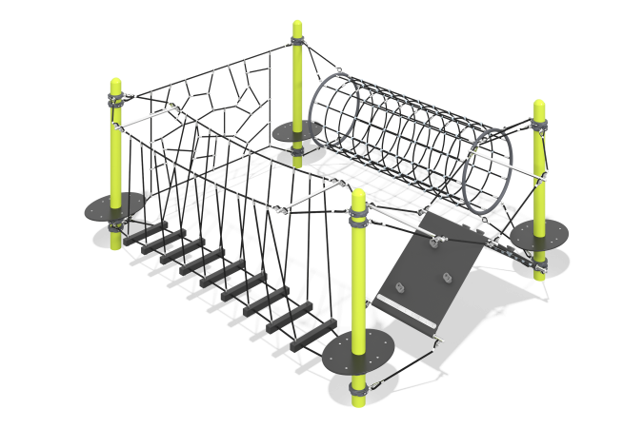

Size, mm: | 3090x4010x2058 | Weight, kg: | 607
Material characteristics
Materials: metal, rope, HDPE plastic, rubber
Complete set: supports - 4 pcs., rope - 1 pc., support platforms - 4 pcs., fastener kit - 1 pc.
Posts made of 133 mm galvanized pipes with powder coating (moire), reinforced 6-strand rope with a diameter of 16 mm, rope connections, plugs on the ends of pipes made of polyamide PA6, steel clamps, beech steps, aluminum alloy compression sleeves, 7 mm thick conveyor belt insert, composite material hooks, platforms on posts made of HDPE plastic with a rubber, anti-slip layer.
Protruding parts of threaded connections and open parts of pipes are covered with plastic plugs
Coating of elements: metal - powder zinc primer, powder paint.

