13.166 |  | Play System Tchaikovsky
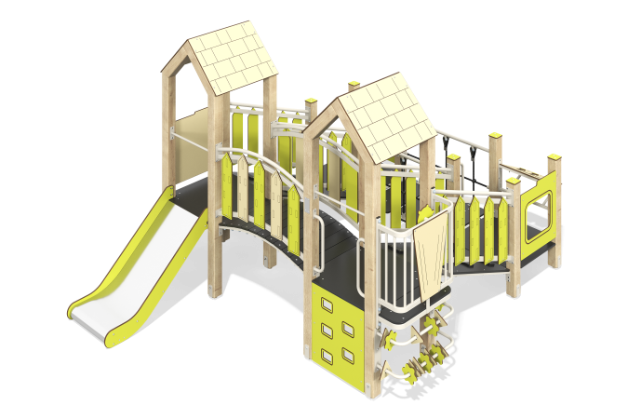

Size, mm: | 3131x4226x2336 | Weight, kg: | 545.632261
Material characteristics
Main materials: softwood timber, planed softwood board, laminated plywood with anti-slip coating, HPL plastic, metal, stainless steel, reinforced polypropylene rope, stainless fasteners.
Contents: embedded parts - 1 set, support posts - 16 pcs., roofs - 2 sets, floors - 1 set, straight slide h=0.7m - 1 pc., fencing and decorative panels - 1 set, inclined ladders with handrails and decorative panels - 2 pcs., arc bridge with decorative fencing - 1 pc., balcony with steering wheel - 1 pc., rope bridge - 1 pc., climber panel with grooves - 1 pc., "Abacus" panel - 1 pc., "Flowers" panel - 1 pc., "Race" panel - 1 pc., handles - 3 pcs., crossbars - 2 pcs., fastening set - 1 pc.
Design and color palette of equipment according to the sketch.
The gaming complex consists of 2 towers and multi-level platforms. The support posts are made of laminated softwood timber with a cross-section of 100x100 mm. The profile is square, the corner radius is R10.
The transition between the towers is presented as:
- a rope bridge made of six-strand reinforced polypropylene rope d=16 mm with steps made of laminated plywood 18 mm thick with an anti-slip coating. The rope bridge railings are made of a metal pipe with a diameter of 42.3 mm and a wall thickness of 2.8 mm.
- inclined ladders made of laminated plywood 18 mm thick with an anti-slip coating and steps made of double-sided HPL plastic with UV protection 10 mm thick.
- an arc bridge consisting of a metal frame made of a metal profile pipe with a cross-section of 40x25 mm and a wall thickness of 2 mm; overlays made of laminated plywood 18 mm thick with an anti-slip coating.
The railings of the arc bridge and inclined ladders are made of a metal pipe with a diameter of 33.5 mm and a wall thickness of 2.8 mm. Decorative panels are made of double-sided HPL plastic with UV protection, 10 mm thick.
The floor frames are planed softwood boards with a section of 100x30 mm, 100x40 mm. The floors and steps are made of laminated plywood 18 mm thick with an anti-slip coating.
The roofs of the towers are gable, made of HPL plastic, the design is applied by engraving.
Fencing and decorative panels, game elements are made of double-sided HPL plastic with UV protection, 10 mm thick. Drawings are applied to panels and game elements using engraving and UV printing.
- climber panels with grooves for legs, made of HPL plastic 10 mm thick;
The handles are made of metal pipe with a diameter of 26.8 mm and a wall thickness of 2.8 mm.
Metal crossbars are made of a round pipe with a diameter of 21.3 mm and a wall thickness of 2.8 mm.
The play complex includes 1 straight slide h=0.7 m. The slide consists of a slope and sides, in turn made of 1.5 mm thick stainless steel sheet and 10 mm thick HPL plastic. The launch pad for the straight slide is equipped with a metal crossbar made of a round pipe with a diameter of 21.3 mm and a wall thickness of 2.8 mm.
The complex uses stainless steel fasteners. Protruding parts of threaded connections and open parts of pipes are closed with plastic plugs.
Element coverage:
- metal - powder zinc primer, powder paint;
- timber - glazing primer, water-dispersion varnish.

