30.006 |  | Wooden curved log
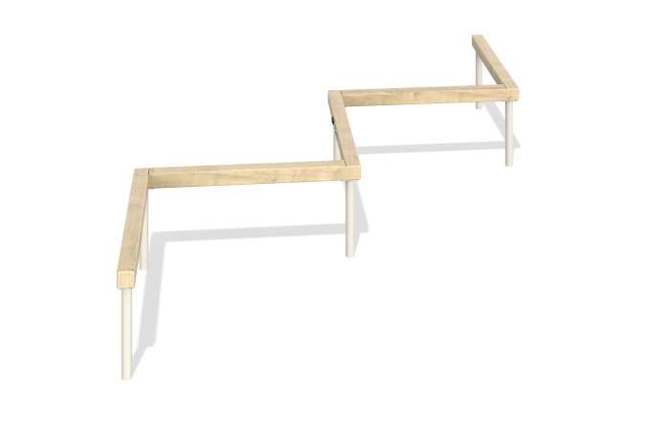

Size, mm: | 2300x2880x500 | Weight, kg: | 35.359
Material characteristics
Main materials: softwood timber, metal.
Contents: embedded parts – 1 set, support posts – 6 pcs., log – 1 pc., fastening kit – 1 pc.
Design and color palette of equipment according to the sketch.
The product is a log consisting of support posts. The racks are made of a 48 mm round pipe with a wall thickness of 3 mm. The log is made of laminated veneer lumber with a cross-section of 80x80 mm. The profile is square, the corner radius is R10.

