32.001 |  | Bike Parking Module
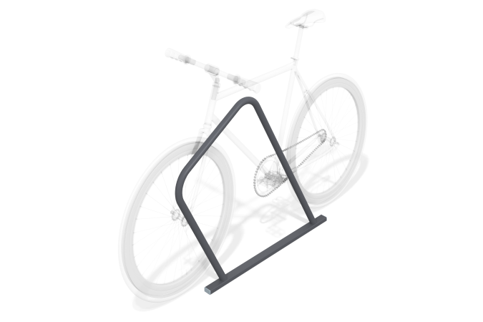

Size, mm: | 60x1164x855 | Weight, kg: | 8.066
Material characteristics
Materials: metal, powder paint.
A profile pipe with a cross section of 60x40mm with a wall thickness of 2mm, and a round pipe with a diameter of 42mm.
The open parts of the profile pipes are closed with plastic plugs.
All available metal parts are painted with polyester powder paint.
The fastening kit is galvanized.
Contents: Module – 1 pc., Mortgage – 2 pcs., Fastening kit – 1 pc., Set of plugs – 1 pc.

