11.017 |  | Seesaw Apples and pears
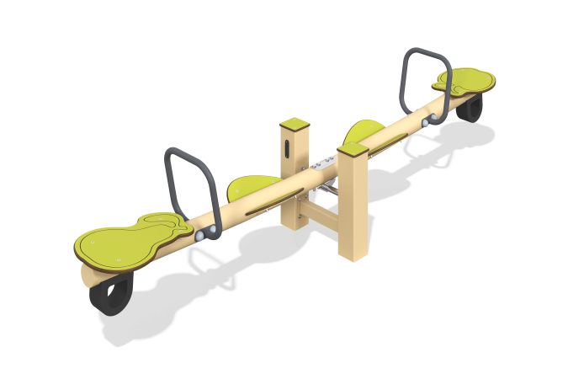

Size, mm: | 482x2648x676 | Weight, kg: | 52.41
Material characteristics
General description of the design
The product is a balancer with handles and seats, pivotally connected to a pipe mounted on two metal posts made of a profile pipe. The balancer seats are decorated with shapes and milling to resemble the outlines of fruits - apples and pears.
Materials and components
Powder-painted structural steel with a layer of zinc-containing primer, HPL plastic, stainless steel fasteners. The handles are made of metal round pipe DN20 with a diameter of 26.8 mm and a wall thickness of 2.8 mm. The main beam is made of a 100x100 profile pipe with a wall thickness of 3 mm.
The maximum angle of inclination of the seat is no more than 20°. Damping is used to prevent sudden stops. The height difference in the extreme positions of the balancer crossbar is no more than 700 mm. The balancer supports are made of 100x100mm profile pipe with a wall thickness of 3 mm. The support unit of the balancer crossbar is made of two bearing supports and a movable axis. The moving part of the support unit rotates in two radial bearings installed in bushings. The protruding metal parts of the metal profiles are covered with plastic plugs.
Frame
It is a metal base of two pillars made of a 100x100 mm profile pipe with a wall thickness of 3 mm, connected to the working part of the balancer made of a pipe with a diameter of 89 mm and a wall thickness of 3 mm through a hinge (bearing module) with one rotational degree of freedom.

