34.266 |  | Topiary Calf
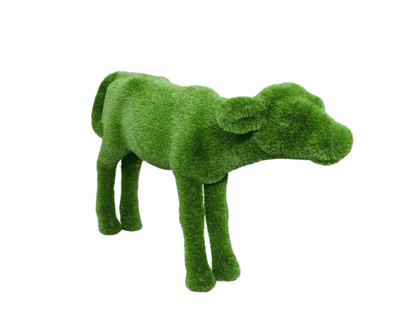

Size, mm: | 1150x1820x620 | Weight, kg: | 0
Material characteristics
Material: fiberglass,
artificial turf.
Included: topiary - 1 pc.

