13.182 |  | Play System Actinium
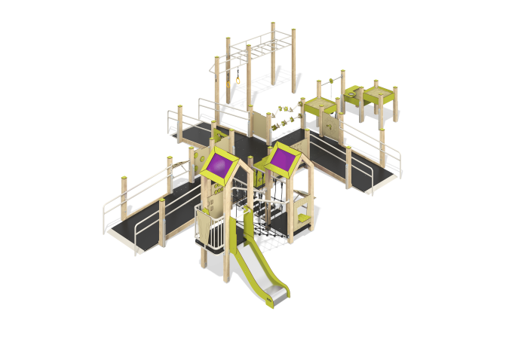

Size, mm: | 7705x9550x2510 | Weight, kg: | 1175.153
Material characteristics
Materials: laminated veneer lumber, HPL plastic 10 mm thick, monolithic polycarbonate 5 mm thick, metal, moisture-resistant plywood 18 mm thick with an anti-slip laminated layer, stainless steel, reinforced polypropylene rope d=16 mm.
The racks of the complex are made of laminated veneer lumber with a section of 100 mm x 100 mm, the profile is standard (R10 - corner radius). The beam is covered on top with a cap made of HPL plastic.
The platforms and ramps of the complex are made of moisture-resistant plywood 18 mm thick, with an anti-slip laminated layer. The fencing and playing panels are made of HPL plastic 10 mm thick. The inclined rope bridge is made of reinforced polypropylene rope d=16 mm, the straight rope bridge is made of reinforced polypropylene rope d=16 mm with steps made of laminated plywood.
Gable symmetrical roofs on a wooden frame made of beams are installed above the two platforms. The roof slopes are made of HPL plastic combined with 5 mm thick polycarbonate, onto which color coating is applied.
The complex consists of one slide 0.7 m high with a slope made of stainless steel sheet 1.5 mm thick. The slide has a starting section with side protection, a sliding and braking section with protective sides made of HPL plastic and a crossbar for safety.
The complex includes three sandboxes on racks made of laminated veneer lumber. Between the two sandboxes there is a metal crossbar on which a sand bucket is attached to a chain. Adjacent to one of the complex’s ramps is a sports section consisting of a metal monkey bars and a crossbar with rings.
Coating of elements: Polymer coating of metal; processing of lumber - glaze primer, water-dispersion varnish. Stainless steel fasteners are used.
Contents: Embedded parts - 42 pcs.; support pillars - 41 pcs.; roofs - 2 pcs. , fencing and play panels - 10 pcs., straight slide - 1 pc., balcony - 1 pc., rope bridge with steps made of laminated plywood - 1 pc., inclined rope bridge - 1 pc., ramps - 3 pcs., sandboxes - 3 pcs., railings - 6 pcs., monkey bars - 1 pc., suspension with rings - 1 pc., attachment "labyrinth" - 1 pc., bent abacus - 1 pc., set of fasteners - 1 pc.

