39.118 |  | Bin
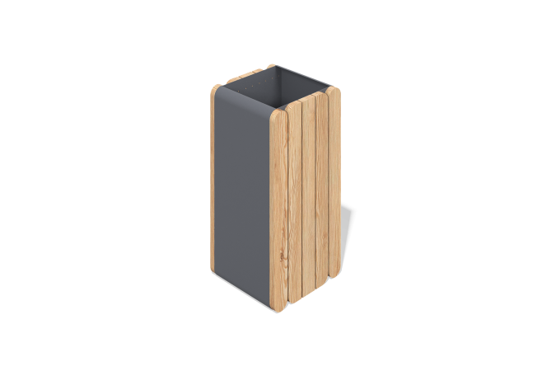

Size, mm: | 390x400x800 | Weight, kg: | 0
Material characteristics
Material: metal and larch.
Metal: steel. The color is powdered. Color: RAL7016.
The wooden part is made of larch wood (color as
agreed), treated with a special impregnation
that reduces water absorption and protective functions (2 layers with intermediate sanding).
Liner material: galvanized steel.

