11.014 |  | Seesaw Fretboard
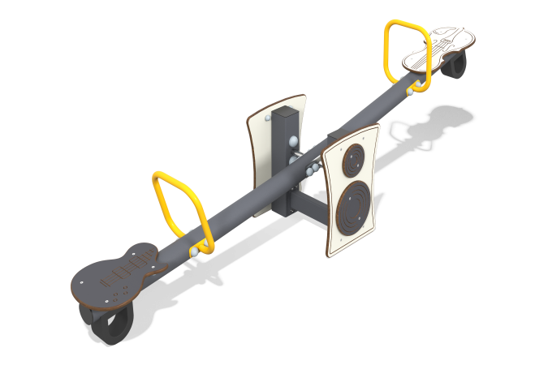

Size, mm: | 526x2650x671 | Weight, kg: | 53.58
Material characteristics
General description of the design
The product is a balancer connected to a pipe mounted on two posts made of a 100x100x3 mm profile pipe. The seats of the balancer are decorated with shapes and milling to resemble the bodies of musical instruments - guitars and violins.
Materials and components
Powder-painted structural steel with a layer of zinc-containing primer, HDL plastic, stainless steel fasteners. The handles are made of metal round pipe DN20 with a diameter of 26.8 mm and a wall thickness of 2.8 mm. The main beam is made of a 100x100 profile pipe with a wall thickness of 3 mm.
The maximum angle of inclination of the seat is no more than 20°. Damping is used to prevent sudden stops. The height difference in the extreme positions of the balancer crossbar is no more than 800 mm. The balancer supports are made of 100x100mm profile pipe with a wall thickness of 3 mm. The support unit of the balancer crossbar is made of two bearing supports and a movable axis. The moving part of the support unit rotates in two radial bearings installed in bushings made of pipe with a diameter of 57 mm. The protruding metal parts of the metal profiles are covered with plastic plugs.
Frame
It is a metal base made of two columns of a 100x100x3mm profile pipe, connected to the working part of a balancer made of a pipe with a diameter of 89 mm and a wall thickness of 3 mm through an axis with one rotational degree of freedom.

