21.029 |  | Rope Climbing Playground Tibet
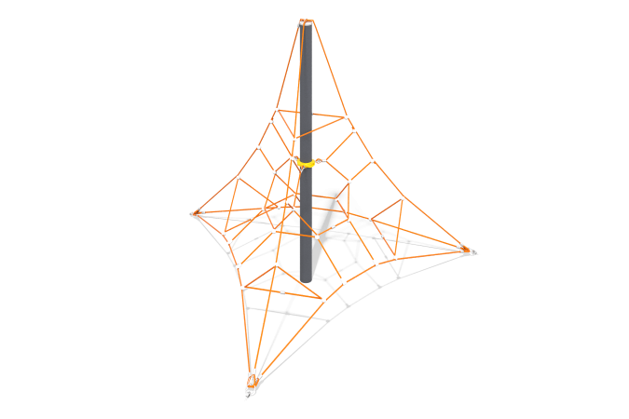

Size, mm: | 4140x4780x2950 | Weight, kg: | 220
Material characteristics
Materials: metal, rope.
Package includes: support post - 1 pc., rope net - 1 pc., fastener kit - 1 pc.
The rope complex consists of a rope part and an installation kit, including a central post and corner embedded parts.
The rope part of the pyramid is a web mesh made of reinforced six-strand rope with a diameter of 16 mm, consisting of polypropylene threads and steel wire. Cross-shaped connectors of the rope part are made of cast polyamide, fixed with stainless steel self-tapping screws 45 mm.
T-shaped connections are implemented using 65 mm long compression sleeves made of aluminum alloys.
The ends of the rope part are threaded in a loop through a metal thimble and fixed with a compression sleeve made of aluminum alloy. The thimbles are equipped with polyethylene inserts that perform a protective and decorative function. The lower ends of the load-bearing slings are equipped with a safety sling, which is fixed to the load-bearing rope with a sleeve made of aluminum alloy from one sling, the free end is threaded with a loop through a metal thimble and fixed with a compression sleeve made of aluminum alloy.
The rope net is fixed to the central post at the top with brackets, in the middle part through a steel clamp.
The support pole is made of a metal pipe with a diameter of 133 mm with a wall thickness of 4 mm, made of high-quality black steel, painted with powder polymer paint resistant to ultraviolet radiation and adverse weather conditions. The load-bearing pole is installed in the central embedded part made of a pipe with a diameter of 108 mm.
The equipment uses stainless steel fasteners. Protruding parts of threaded connections and open parts of pipes are covered with plastic plugs
Coating of elements: metal - powder zinc primer, powder paint.

