35.032 |  | Dog Playground Rings
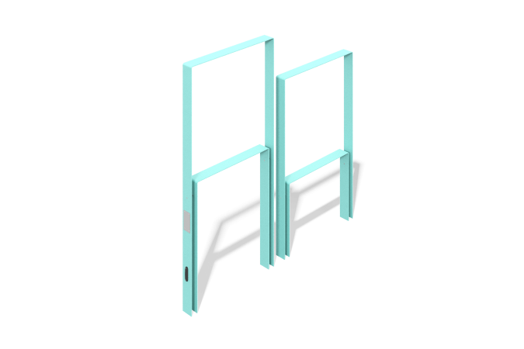

Size, mm: | 80x1530x1500 | Weight, kg: | 54.3671
Material characteristics
Materials: metal
The "Rings" element is a dog equipment consisting of two sections.
The design is a solid rectangular frame mounted on two posts.
The frames are made of a 5 mm thick sheet.
The product is painted with polymer paint.
Equipment:
large ring - 1 piece,
small ring - 1 piece,

