37.003 |  | Scientific module Musical instruments
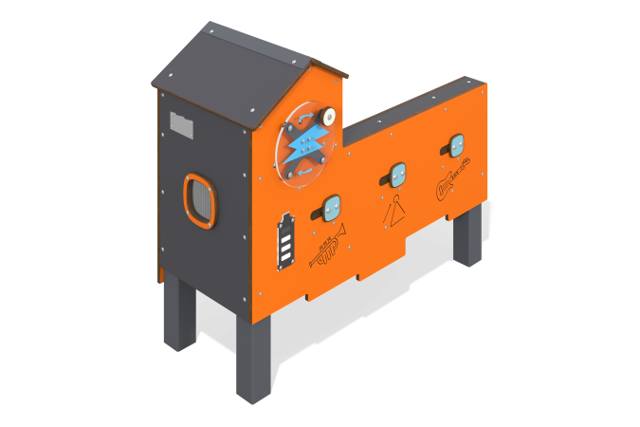

Size, mm: | 567x1222x1013 | Weight, kg: | 338.306
Material characteristics
Educational game module
The module is a “musical instruments” installation with an integrated bench on metal stands. The musical installation consists of a generator set with connected sensors and a speaker located inside a housing made of HPL plastic. The case is equipped with a charge indicator in the form of a battery, a rotating panel made of monolithic polycarbonate with a handle, the rotation of which charges the generator. The body has slots with sliders. By moving the sliders when the generator is charged, various musical instruments playing a programmed melody are turned on and off.
On the back side of the module there is a bench with a seat made of planed softwood boards.
Materials: HPL plastic, planed board, monolithic polycarbonate, metal, electronic components.

